Title*: | Branching and tagging strategy for Forge repository
from Source*: | ETSI
Contact: | Michele Carignani
input for Committee*: | NFV TST
Contribution For*: | Decision | X
 | Discussion
 | Information
Submission date*: | 2020-02-20
Meeting & Allocation: | NFVTST#135-F2F Sophia Antipolis -
Relevant WI(s), or deliverable(s):

Decision/action requested: Please approve

ABSTRACT: R1 adds fixes agreed during the meeting.

Branching strategy

The project shall contain two types of permanent branches:

- Master branch: which shall contain the content related to the latest published version of the latest release;
- Release branches: which shall contain the content related to the latest published version for the previous releases, i.e. not the most recent release with published version available. The release branches shall follow the format Release-AB, where AB are the two digits indicating the release number.
Other temporary branches may be created with the scope of containing:

- Drafting branches: which shall contain the content related to the latest available draft for the document, or the latest accepted contribution on top of a certain active work item. The name of the branch shall follow the format A.B.C-drafts, where A, B and C indicate the target publication version.
Individual contributions (or set of commits forming one contribution), or
Integration of several contributions approved in the same scope (e.g. during the same meeting).

Tagging strategy

On both master and release branches the git tags shall identify the different published versions. The tag format shall be vA.B.C, where A, B and C identify the publication version.
On the drafting branches, the tags indicate the different drafts available. The format of the tags on drafting branches shall be A.B.C.D.E.F, indicating the six digits of the version number for NFV-TST 010 drafts.

Labels

FFs.

Graphical view

Figure 1 depicts the development and relationship of branches, with time flowing bottom-up. Yellow dots indicate the different commits and red dots indicate Merge Requests. On the right side, the high level view including the evolution of the master branch over different releases.

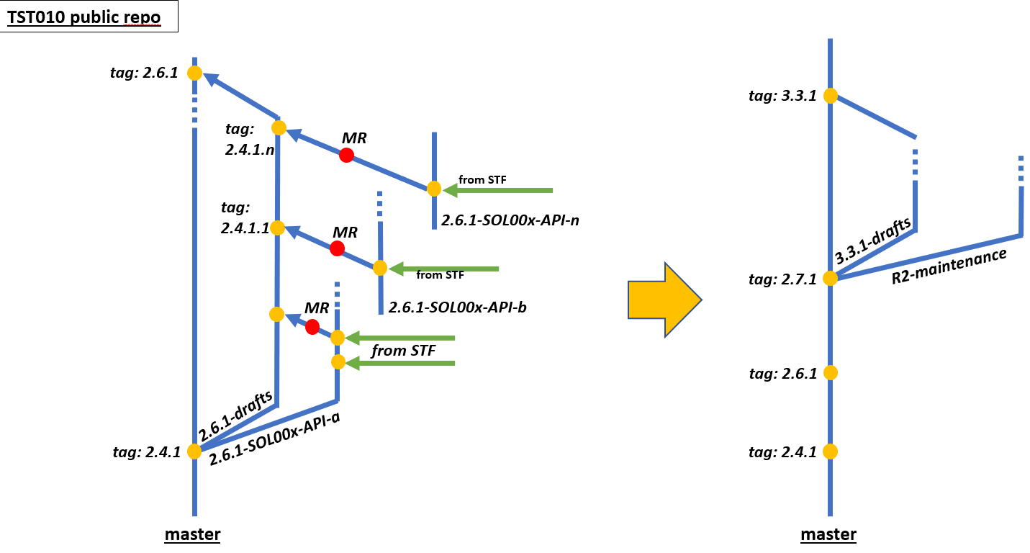
Figure 1

Summary

 | Name format | Content | Tags indicate…
Master branch | Master | Latest published version for the latest release | Published version
Release branches | Release-AB | Latest maintenance version for previous releases | Published version
Drafting branches | A.B.C-drafts | Latest draft for an active WI or latest merged contribution | Drafts
Other branches | * | Contributions or partial integrations | Freely assigned by the contributor

